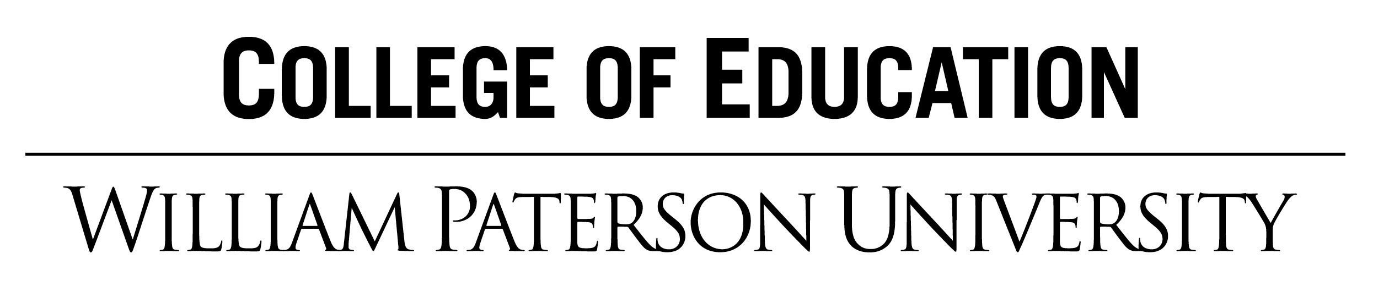

Permission to Video Record and Live Stream for Educational Purposes

Dear Parent/Guardian:

As part of obtaining my teaching license I am required to be observed teaching in your child’s classroom a minimum of eight times by my William Paterson University clinical supervisor. The primary focus of the videotapes is on my instruction and not on the students in the class.

Normally, these observations are conducted in person within the classroom. During the 2020/2021 school year, these observations will be conducted remotely to reduce the number of people entering school buildings and provide the opportunity for my remote teaching to be evaluated.

There are a few ways for my remote observations to be completed using secure video recording and live streaming technology. The only person who will have access to the video recording or live stream is the clinical supervisor. During the course of video recording and live stream, your child may appear.

I am requesting your permission to allow your child to participate as part of the secure, digital observations of my classroom instruction. All materials will be kept confidential and secure.

Sincerely,

_____________________________________
(Clinical Intern – Student Teacher)

Permission Slip (Return to your child’s teacher)

Student name____________________________________________________________

Address__________________________________________________________

School/Teacher____________________________________________________

I am the parent/legal guardian of the student named above. I have received and read your letter regarding the videotaping for [teacher certification, student teaching, National Boards].

- I give permission to you to include my child’s image in videotape as he or she participates in your class.

- I do not give permission to videotape my child.

Signature of parent or guardian____________________________________________

Date_________________________________________

